**Introduction:**

**Over view and purpose:**

["Unveiling Market Insights" is a book that discusses the power of mass psychology in chart analysis](https://www.bing.com/ck/a?!&&p=881085f89ad7da14JmltdHM9MTY5NzE1NTIwMCZpZ3VpZD0xMjcxNmY4MS1hNDUwLTY0OTQtMzc4YS03ZTI4YTVmZDY1N2MmaW5zaWQ9NTU2NA&ptn=3&hsh=3&fclid=12716f81-a450-6494-378a-7e28a5fd657c&psq=unveiling+market+insights+description&u=a1aHR0cHM6Ly90YWN0aWNhbGludmVzdG9yLmNvbS9jaGFydC1hbmFseXNpcy8&ntb=1). [It explains that significant developments occur when neutral readings surge into the 50-55 range, with higher readings carrying greater significance. This surge signifies deep uncertainty as both bears and bulls struggle with decision-making, causing them to avoid the markets. Market insights, on the other hand, are the discovery of a relevant, actionable and previously unrealized reality about a target market as the result of deep, subjective data analysis](https://www.bing.com/ck/a?!&&p=bf0c83b301ea8eafJmltdHM9MTY5NzE1NTIwMCZpZ3VpZD0xMjcxNmY4MS1hNDUwLTY0OTQtMzc4YS03ZTI4YTVmZDY1N2MmaW5zaWQ9NTU2Ng&ptn=3&hsh=3&fclid=12716f81-a450-6494-378a-7e28a5fd657c&psq=unveiling+market+insights+description&u=a1aHR0cHM6Ly91bWktaW5ub3ZhdGlvbi5jb20vYmxvZy9tYXJrZXQtaW5zaWdodC1kZWZpbml0aW9uLw&ntb=1). [Market research is the process of gathering and analysing data to gain insights into a particular market, industry, or consumer behaviour](https://www.bing.com/ck/a?!&&p=fcdfadec518271bdJmltdHM9MTY5NzE1NTIwMCZpZ3VpZD0xMjcxNmY4MS1hNDUwLTY0OTQtMzc4YS03ZTI4YTVmZDY1N2MmaW5zaWQ9NTU2OA&ptn=3&hsh=3&fclid=12716f81-a450-6494-378a-7e28a5fd657c&psq=unveiling+market+insights+description&u=a1aHR0cHM6Ly93d3cucHJvZHVjdGluc2lnaHRzLmNvbS91bnZlaWxpbmctbWFya2V0LWluc2lnaHRzLXRoZS1wb3dlci1vZi1tYXJrZXQtcmVzZWFyY2gtaW4tbmV3LWplcnNleS8&ntb=1).

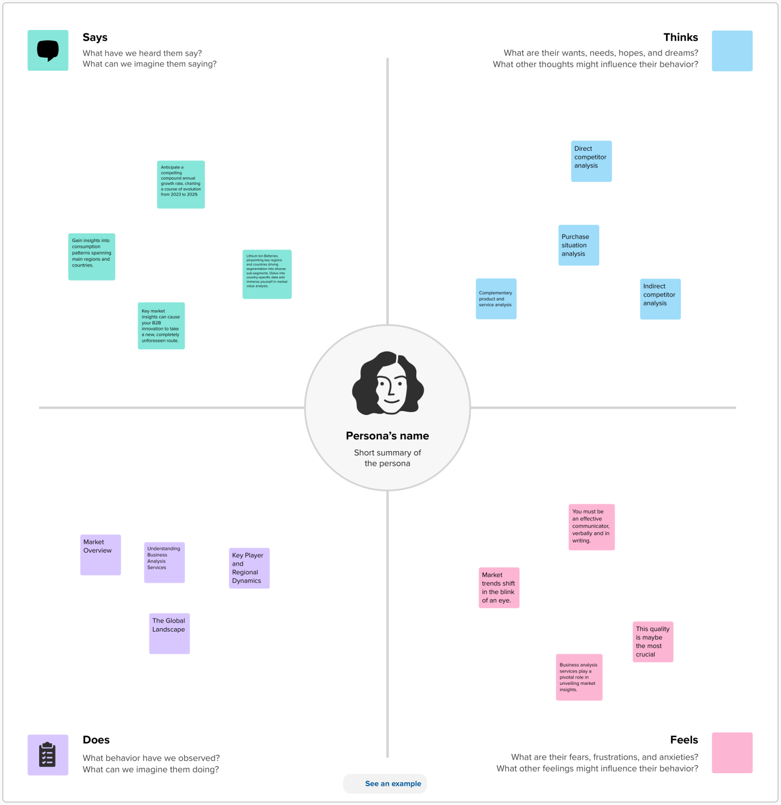**Problem definition and design thinking**:

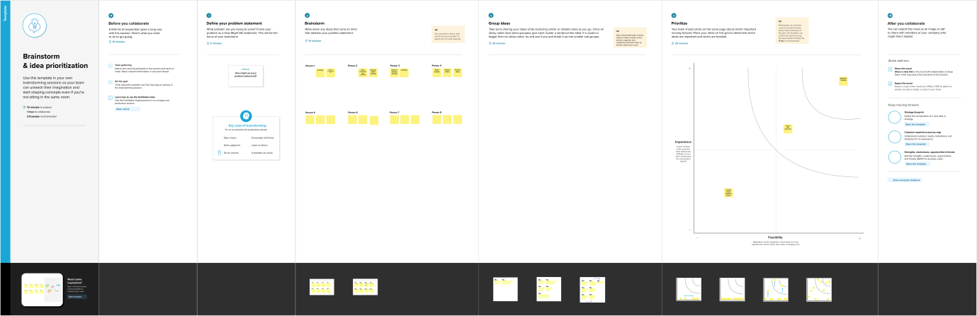

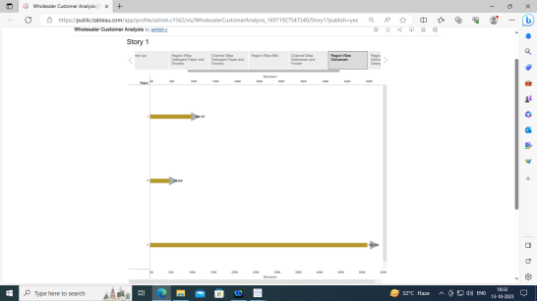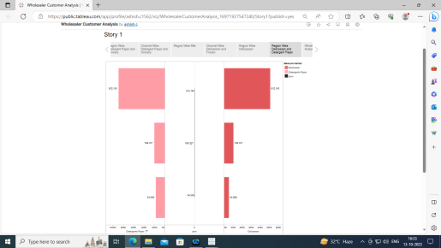**Result**: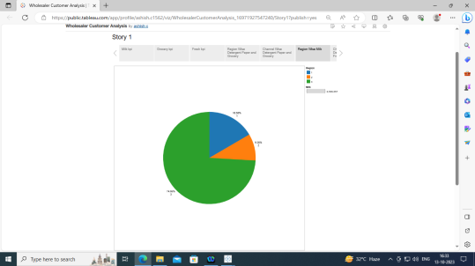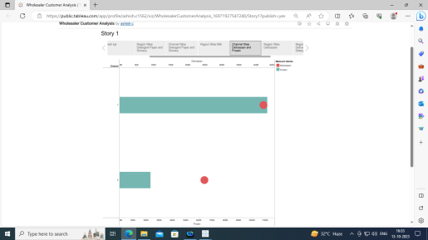

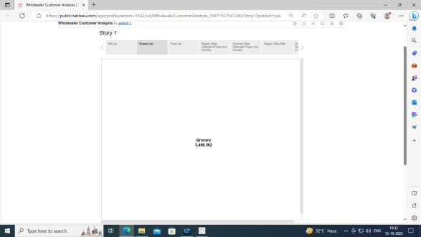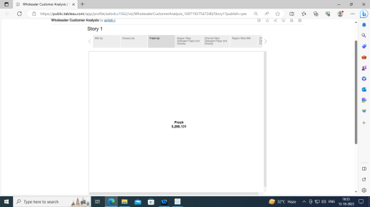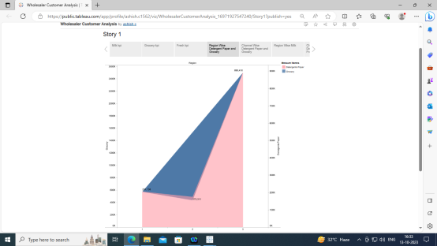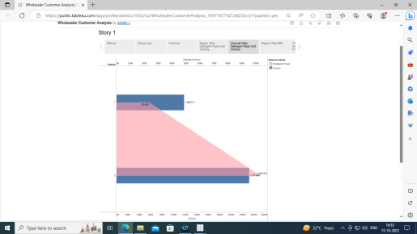:

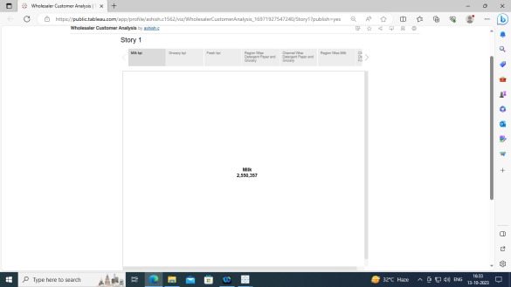

**Conclusion:**

We have created the story for Milk kpi, Grocery kpi, Fresh kpi, Region Wise Detergent Paper and Grocery, Channel Wise Detergent Paper and Grocery, Region Wise Milk, Channel Wise Delicassen and Frozen, Region Wise Delicassen, Region Wise Delicassen and Detergent Paper, Wholesaler Customer Analysis Dashboard.